Data Analytics



SESSION 2: INTRODUCTION to working with R

Assignment 3

Mail id:Udaykumarr019@gmail.com

MOB:8123431864

**Problem Statement**

* 1. How to Import SAS XPORT Files into R With The foreign package.

**ANS:** To import SAS XPORT file into R with the foreign package , we need to install the foreign package and then we need to call the package using library command .

**Commands:**

**install.packages("foreign")**

**library(foreign)**

**read.xport("C:/Users/Daksh/Downloads/xport-0.3.0/test/data/test.xpt")**

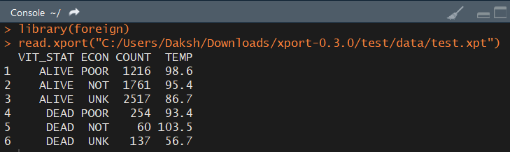

**2.** How To Import SAS Files into R With The haven Package?

**ANS:**To import SAS files into R with the haven Package:

1. Install package
2. to use library command to use the package

**command:**

**library(haven)**

**read_sas(file.choose())**

# after running the above command it will give option to chose the file which we want to run

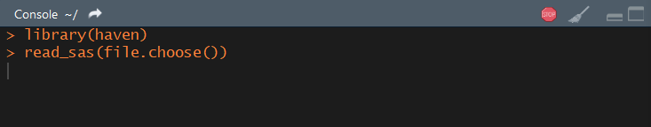

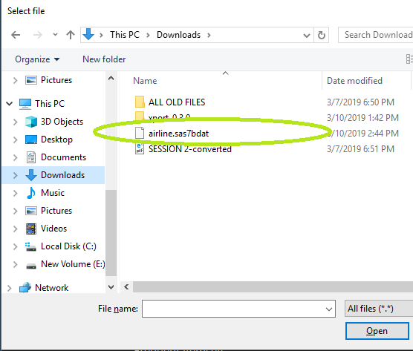

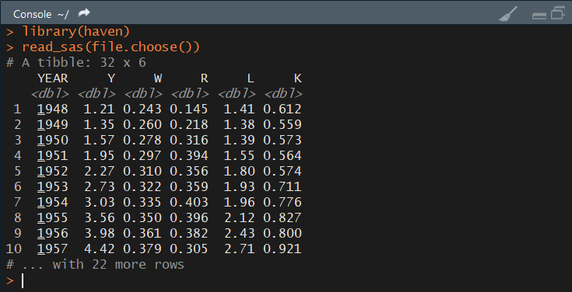

3. How to read Weka Attribute-Relation File Format (ARFF) files in R?

ANS: To read Weka Attribute-Relation file format(ARFF) in R, we to load the

“**library:Foreign**”

COMMAND:

**library(foreign)**

**read.arff(file.choose())**

# after running the above command it will give option to chose the file which we want to run

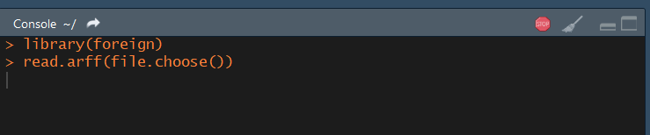

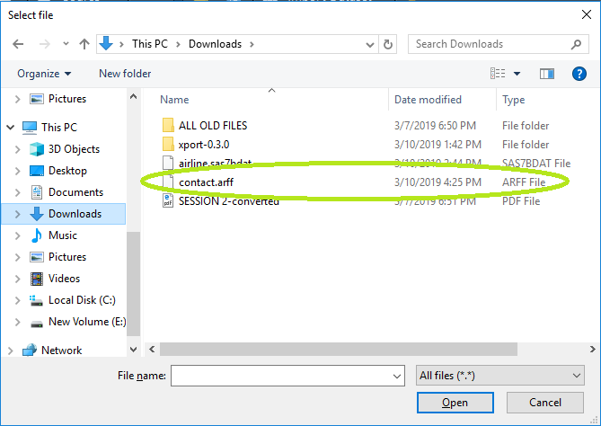

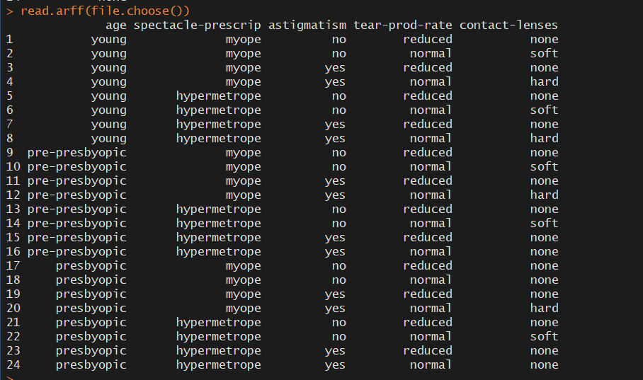

1. How to read a heavy csv/tsv file using readr package?

ANS: To read a heavy CSV/TSV file using “readr package”, we need to load the package using library command.

COMMANDS:

library(readr)

read.csv(file.choose())

# after running the above command it will give option to chose the file which we want to run

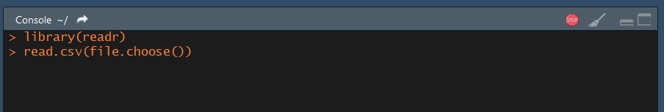

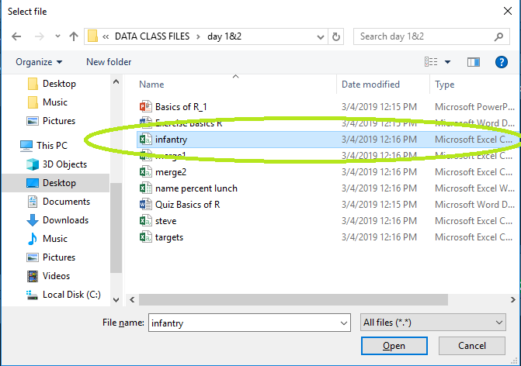

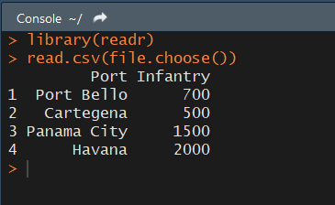

**#to open TSV file using readr package**

**COMMAND:**

**library(readr)**

**read_tsv(file.choose())**

# after running the above command it will give option to chose the file which we want to run

